Azure Resource Group Creation: -

1. Sign in to the [Azure portal](https://portal.azure.com/).
2. Select **Resource groups**

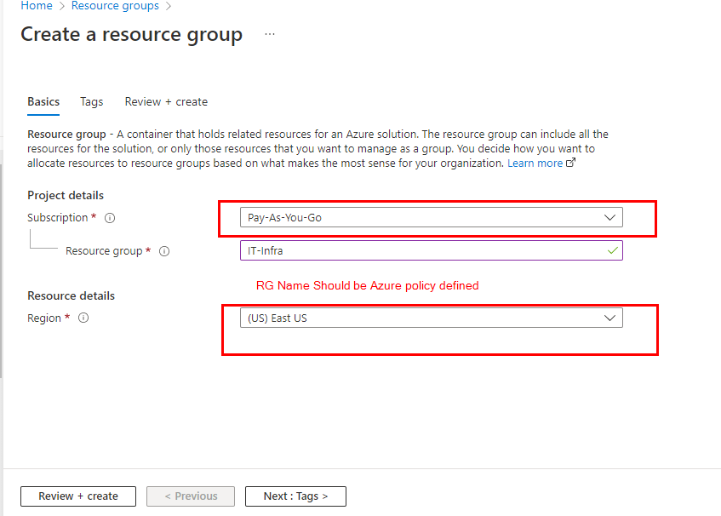

Select **Add**.

Enter the following values:

1. **Subscription**: Select your Azure subscription.
2. **Resource group**: Enter a new resource group name.
3. **Region**: Select an Azure location, such as **East US**
4. Select **Review + Create**
5. **Create**